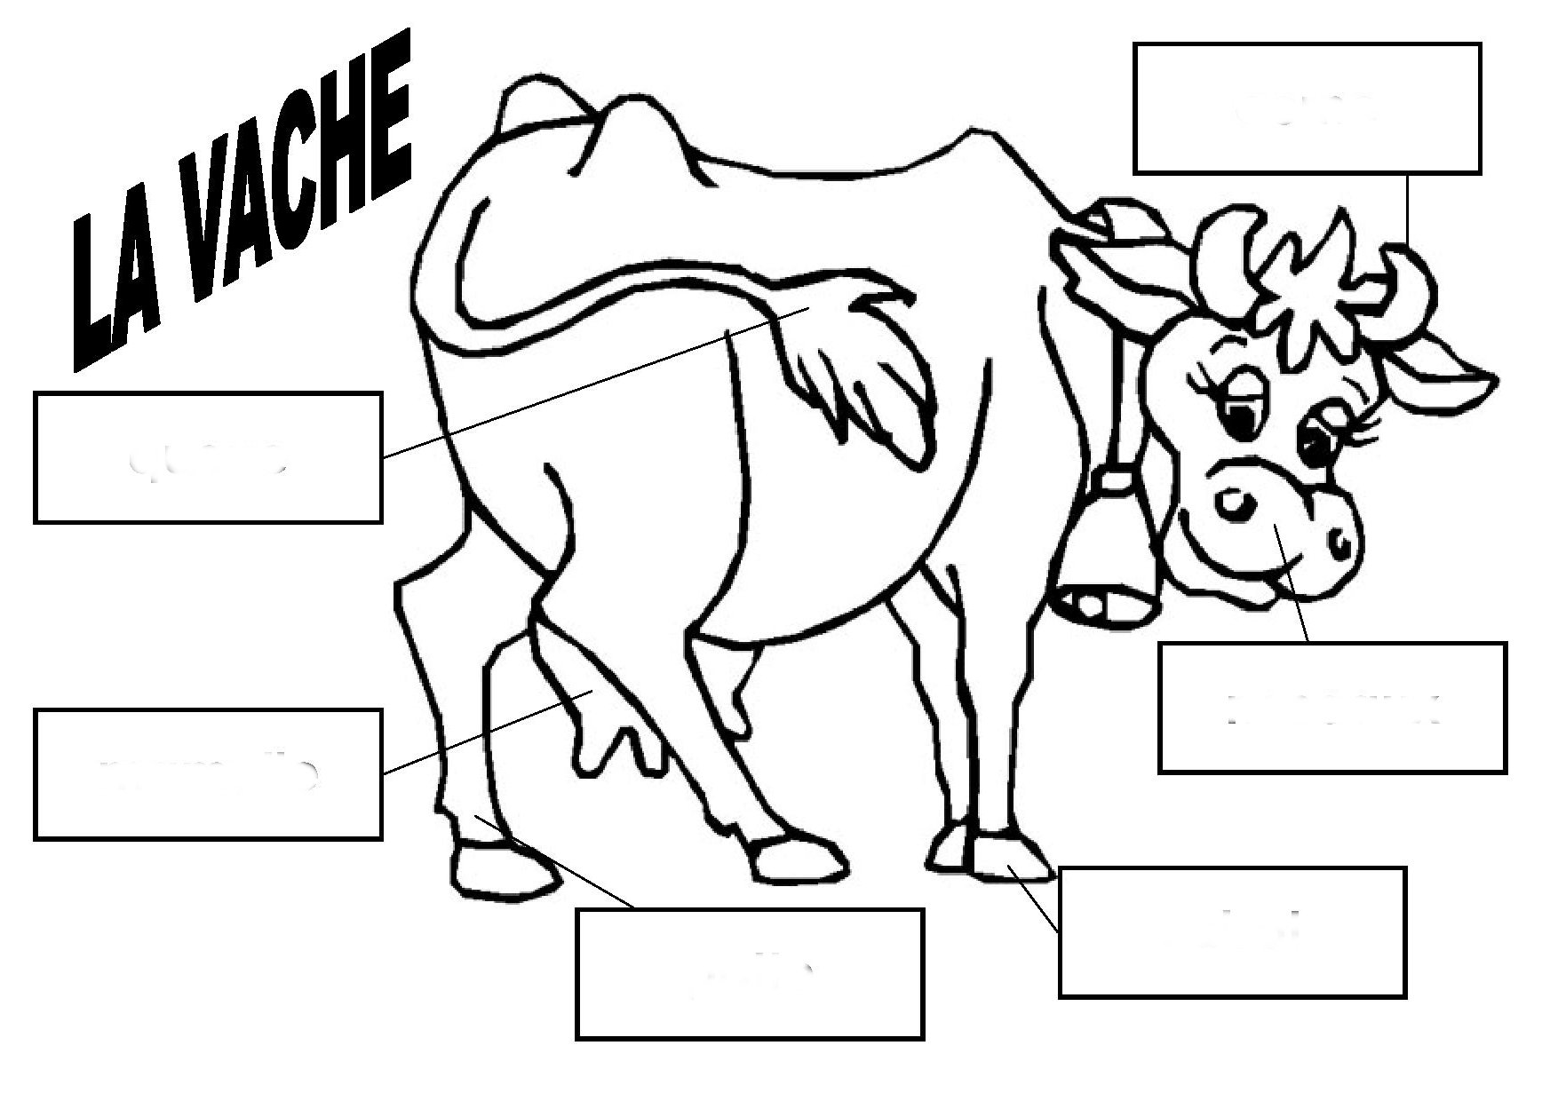
cornes | mamelle | pattes | queue | sabot
naseaux

cornes | mamelle | pattes | queue | sabot
naseaux

cornes | mamelle | pattes | queue | sabot
naseaux

